Final Project Report: Exploring Global Trade Network

BIA 658 Social Network Analysis

May 11, 2021

Darpan Shah, Nishitha Reddy Dodda, Nuozhou Tang

**TABLE OF CONTENTS**

1. Highlights and Executive Summary…………………………………………………… 2
2. Introduction and Data Understanding…..……………………………………………… 3
3. Methodology...……………………………………………………...………………….. 5
4. Analysis….……………………………………………….…………………………….. 6
5. Conclusion……………………………………………………………………………… 9
6. Reference……………………………...……………….……………………………… 10

**HIGHLIGHTS**

* This report explores the World Trade from 2000 to 2018 using Social Network Analysis and introduces the reader to some of the techniques used to visualize, calculate and represent network trade data.
* We are able to show different visualizations of the network and describe its topological properties and explored some of the network algorithms.
* So through this overall we want to provide a picture of how international trade has changed over the two decades.

**EXECUTIVE SUMMARY**

This report is a conglomeration of all the analytics and insightful information to understand how the trade network is emerging amongst countries over a span of two decades affected by its Social Network. We have observed that interestingly, the global trade network is getting decentralized and the wealth gap between rich countries and poor countries seems to be wider than ever before. In this project, the goal is to un-veil the reasons behind the huge wealth gap we are facing right now using just the social network to analyze the world-trade-network evolution. Data for 161 countries and their ties with other countries along with the weight of trade has been extracted from Kaggle to perform various network analytics. We were able to get some very insightful take-away while understanding the dynamics of global trade networks and address economic problems using just a few social network Analytic techniques where it seems surprising it was always expected to get such insights by big-data analytics. This project discusses world-trade-network on a global scale and will provide detailed analysis of selected countries individually.

**INTRODUCTION**

Today, most of us can walk into a local grocery store and are able to pick up products from all over the world or the electric car you just purchased is made by the parts manufactured at factories from different counties. Thanks to a world-trade-network that has never been more closely connected in mankind’s history.

Trade is a basic economic concept involving the buying and selling of goods and services, with compensation paid by a buyer to a seller, or the exchange of goods or services between parties. Trade can take place within an economy between producers and consumers. Global trade allows countries to expand markets for both goods and services that otherwise may not have been available to it. It is the reason why an American consumer can pick between a Japanese, German, or American car. As a result of international trade, the market contains greater competition and therefore, more competitive prices, which brings a cheaper product home to the consumer.

Global trade not only results in increased efficiency but also allows countries to participate in a global economy, encouraging the opportunity of [foreign direct investment](https://www.investopedia.com/terms/f/fdi.asp) (FDI), which is the amount of money that individuals invest into foreign companies and other assets. So with the help of social network analysis

Social network analysis is the mapping and measuring of relationships and flows between people, groups, organizations, computers, URLs, and other connected information/knowledge entities. The nodes in the network are the people and groups while the links show relationships or flows between the nodes. Itprovides both a visual and a mathematical analysis of human relationships. In our case the nodes represent the countries and the links represent the trade relations among those countries.

**DATA UNDERSTANDING**

|  |  |
| --- | --- |
| **Id** | **Label** |
| 85 | KIR |
| 25 | BTN |
| 123 | PLW |
| 36 | COM |
| 146 | TON |
| 10 | BDI |
| 4 | ARG |
| 141 | TCD |
| 60 | GNB |
| 159 | ZAF |
| 20 | BMU |
| 41 | DMA |
| 70 | HUN |

The data was acquired from an online platform “Kaggle”. Our database includes data from 2000 to 2018 with the list of source and target countries trade and the volume of trade. Apart from the volume we have one more attribute named “Population” for each country. The visualization tool which was used is Gephi and to perform analysis we used R software.

|  |  |  |  |
| --- | --- | --- | --- |
| **Source** | **Target** | **Weight** | |
| 1 | 2 | 58 | |
| 1 | 3 | 1,900,756 | |
| 1 | 4 | 52,701 | |
| 1 | 5 | 54 | |
| 1 | 6 | 461 | |
| 1 | 7 | 48,280 | |
| 1 | 8 | 21,346 | |
| 1 | 9 | 763 | |
| 1 | 11 | 1,056,896 | |
| 1 | 12 | 1,269 | |
| 1 | 13 | 40 | |
| 1 | 14 | 1,195 | |
| 1 | 16 | 1,017 |

Sample Data:

Nodes

Edges

**METHODOLOGY**

Node Degree:

It is the number of relations of the nodes in the entire network. However in the case of the directed networks, we distinguish between in-degree and out-degree of a vertex. In our network the degree also have weights with it hence we have to do our analysis on weighted degree.

Density:

The density of a graph is a measure of how many ties between actors exist compared to how many ties between actors are possible.

The density of a network property is important to consider for two reasons. First, it can help us understand how connected the network is compared to how connected it might be. Second, when comparing two networks with the same number of nodes and the same type of relationships, it can tell us how the networks are different.

Centrality:

It uses graph theory to calculate the importance of any given node in a network. There are four kinds of centrality:

1. Degree Centrality – the more the degree of a node, higher would be its degree centrality
2. Closeness Centrality – it calculates the distance of a node to all the rest of the nodes in the network
3. Betweennes Centrality – it shows which nodes are bridges between nodes in the network, calculated by counting all the shortest paths in the network.
4. Eigenvector Centrality – it measures how influential a node is in the network, determined by its connections in the network

Modularity:

It is a measure of the structure of networks or graphs which measures the strength of the division of a network into different groups.

**ANALYSIS**

Firstly we will look into the density of the network. Below graph shows that over the period of time density of the network has increased which refers that countries are more linked in comparison to previous years.

Our trade network of year 2000 looks like this:

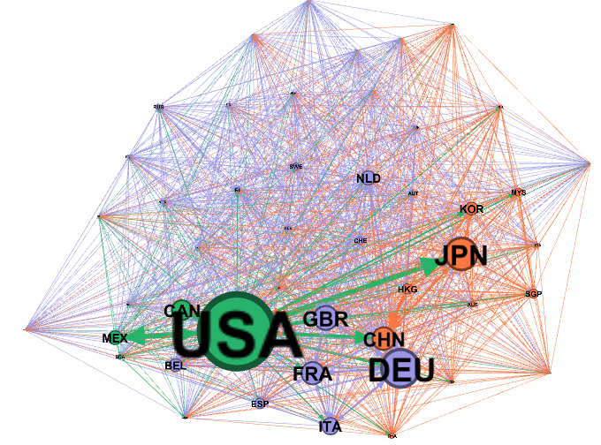

|  |  |
| --- | --- |
| **Country** | **Contribution** |
| USA | 17% |
| Germany | 10% |
| Japan | 9% |
| China | 9% |
| France | 8% |

Year-2000

Here the size of the node is displaying the contribution of the country in the total world trade and the color represents community which is 3. So some countries are popping out and are bigger than the rest which are USA, China, Germany, Japan, France etc. Hence we can say that there is centralization in the network and these are the leaders of the network.

Now if we compare the above network of year 2000 with the year 2018 we can see that the contribution has changed and hence other countries are coming up.

|  |  |
| --- | --- |
| **Country** | **Contribution** |
| USA | 11% |
| Germany | 9% |
| Japan | 6% |
| China | 11% |
| France | 5% |

Year-2018

If we compare the two years map we can see that where in 2000 USA was at the top with majority of world trade in 2018 the trade contribution has changed a lot and other countries like China and Germany has grown a lot. This shows that the centralization is decreasing over the time.

We observed that top contributors have changed their clusters and thus resulting in change their color like China changed to blue and Germany changed to orange.

We can also see that some new countries have also started to come into existence which were not there in the year 2000 like India, Hong Kong, Russia etc.

**Rich Club:**

We found that there is a change in the distribution of trade so we tried to list top 20 countries in 2000 as Rich Club and compare their positions over the 2 decades.

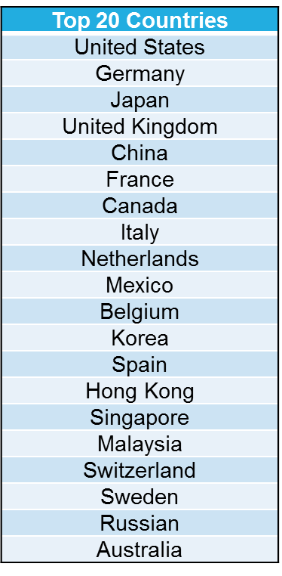**

Here we can see that the contribution is decreasing with great pace from 80% in 2000 to 71% in 2018. Thus we can say that overall centralization is decreasing in the network over two decades.

**ERGM:**

ERGM is one of the modeling techniques used in stochastic social network analytics. This modeling treats the network as realizations of random variables and purpose a model for the distribution of those variables. It has proved to be very useful in sociological research which talks about homogeneity, attribute significance in the network holistically.

In our project, we picked one comparatively static attribute, which is the **population** of the country and added the same to the data set. Population being a country’s attribute, we have visualized it as a node attribute and investigated the significance of the same in export and import tie formation in global trade. We have included only those parameters in our model which had significance and discarded the rest.

Form the above analysis, I can see that the network is highly dense which is evident from previous analysis, it exhibits high reciprocity which means that countries tend to from import ties with the ones they have export ties with and vice versa. On another note, countries with low population tend to export more.

Countries tend to form ties with countries with the same levels of population as them, which again is an interesting insight which can a drive country’s decision when forming allies.

**CONCLUSION**

Our analysis demonstrates that the global trade network has not been like the way it is, all along. Over a span of time, the factors affecting globalization as well as centralization tend to change. It is also justified by the fact that centralization has exhibited a decreasing trend suggesting that power is not concentrated among those countries which were the highest contributors in the year 2000. In the current trade world, we see the budding countries like India, Russia and Thailand which are making their mark in the world’s total trade indicating that centralization is bound to show declining effect. When given a thought, this makes us explore further why the wealth gap still exists when the network is getting decentralized, wasn’t it supposed to be improving? The plausible answer to this could be explained by our weighted out-degree and in-degree comparative analysis which shows that there are a few countries like Zimbabwe, Sri Lanka, countries of Africa which have nil exports and are dependent on many trade dominating countries to fulfill their needs. Now, the factors leading to this can vary from country to country depending on their economic standing, resources, and liabilities. This of course leads to a wealth gap when one is always at the receiving end and the other at the giving, when the network setting deals with money.

Now, talking about the significance that population holds with tie formation which could explain the prior mentioned key findings of our project. We observed that population has a certain significance, especially with the outgoing tie which denotes the exports. And one more interesting insight is that countries with similar levels of population tend to come together for trade.

**REFERENCES**

* De Benedictis, L. and Tajoli, L., 2011. The world trade network. *The World Economy*, *34*(8), pp.1417-1454.
* Scott, J., 1988. Social network analysis. *Sociology*, *22*(1), pp.109-127.
* Carrington, P.J., Scott, J. and Wasserman, S. eds., 2005. *Models and methods in social network analysis* (Vol. 28). Cambridge university press.
* Lincoln, M., 2016. Social Network Centralization Dynamics in Print Production in the Low Countries, 1550-1750. *International Journal for Digital Art History*, (2).
* Wang, P., Robins, G. and Matous, P., 2016. Multilevel network analysis using ERGM and its extension. In *Multilevel network analysis for the social sciences* (pp. 125-143). Springer, Cham.